**JBoss Enterprise Middleware Suite (JEMS):**

• Application Server (JBoss AS, Tomcat)

• O/R Mapping and Persistence (Hibernate)

• Portal Platform (JBoss Portal)

• Business Process Management and Rules (JBoss jBPM, JBoss Rules)

• Object/Data Cache (JBoss Cache)

• Distributed Transaction Management (JBoss Transactions)

• Development Tools (JBoss Tools plugin for Eclipse)

Apache Tomcat= Web Server (HTTP Server- protocols-HTTP,HTTPS,FTP tech:HTML,CSS,Javascript) + Servlet Container + JSP Container

Application Server=- Web Server (HTTP Server- protocols-HTTP,HTTPS,FTP tech:HTML,CSS,Javascript) + Servlet Container + JSP Container) + EJB Container

JBOSS Application= Full Application Server=(Apache Tomcat + EJB Container)

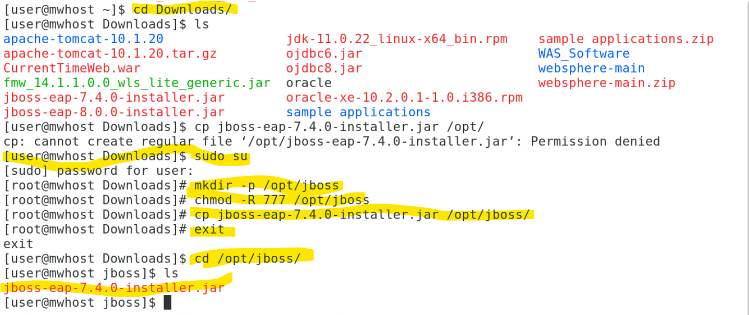

Steps to Install JBOSS EAP (Enterprise Application Server)



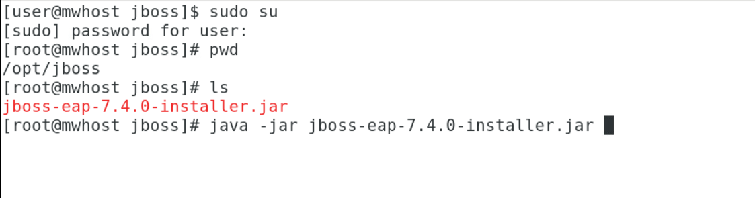

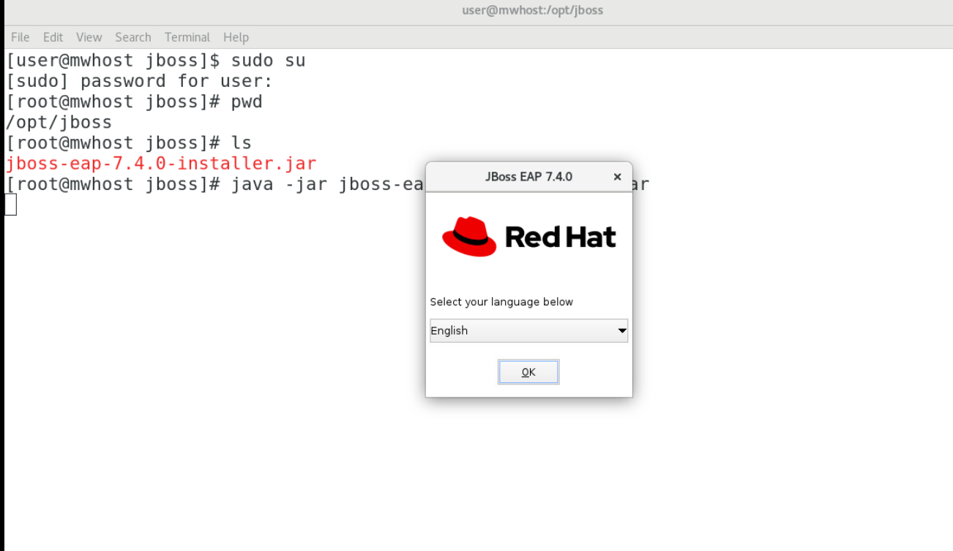

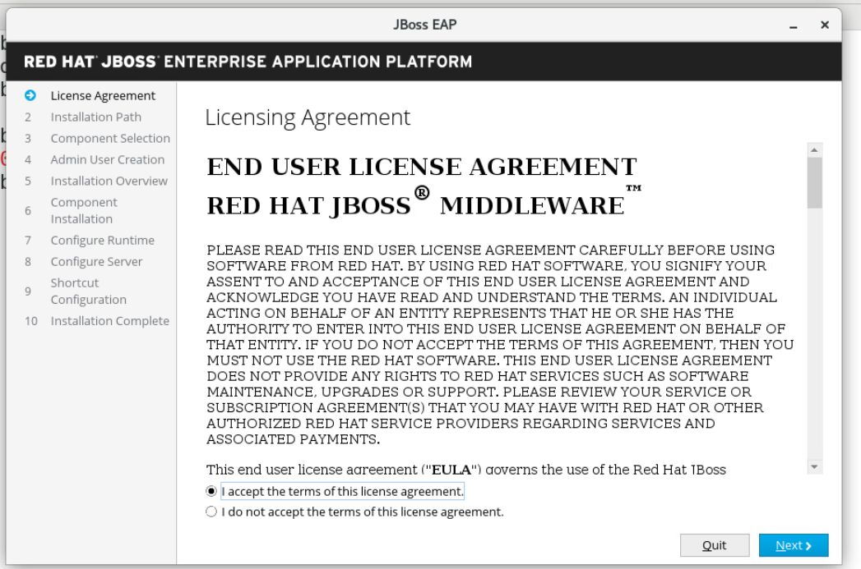

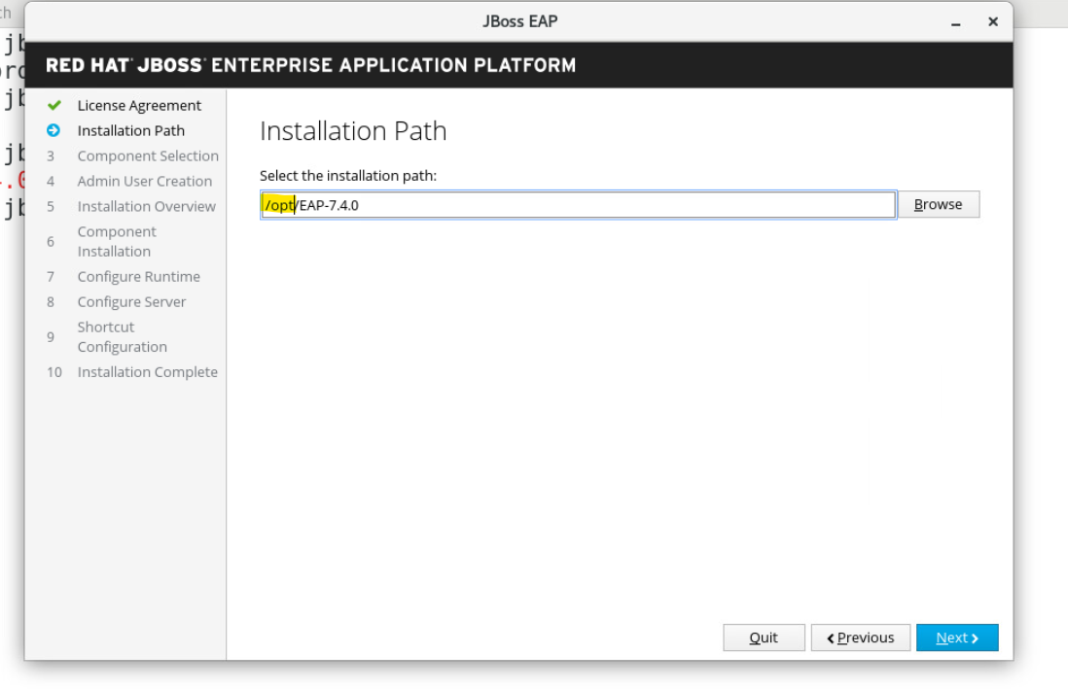

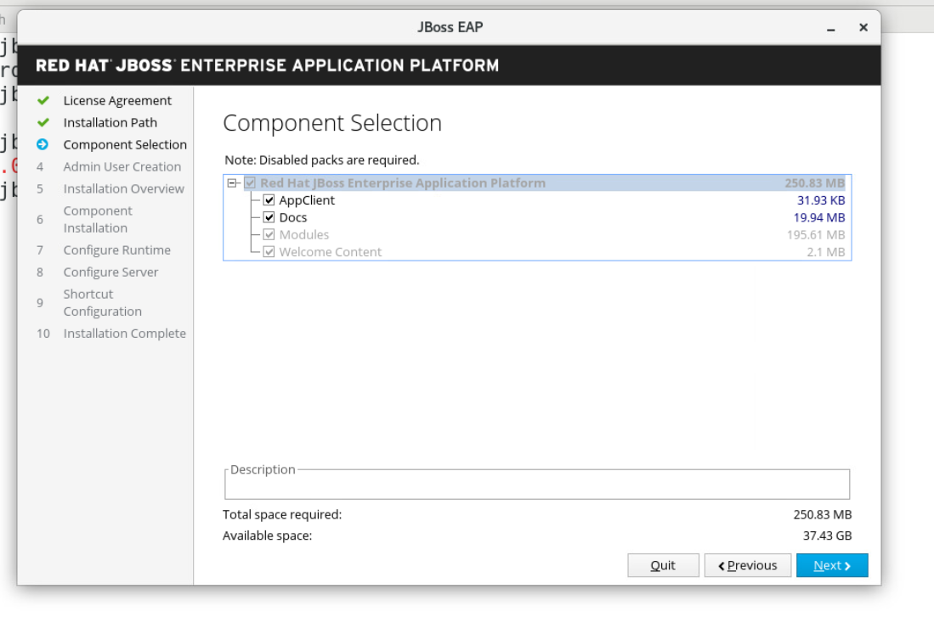

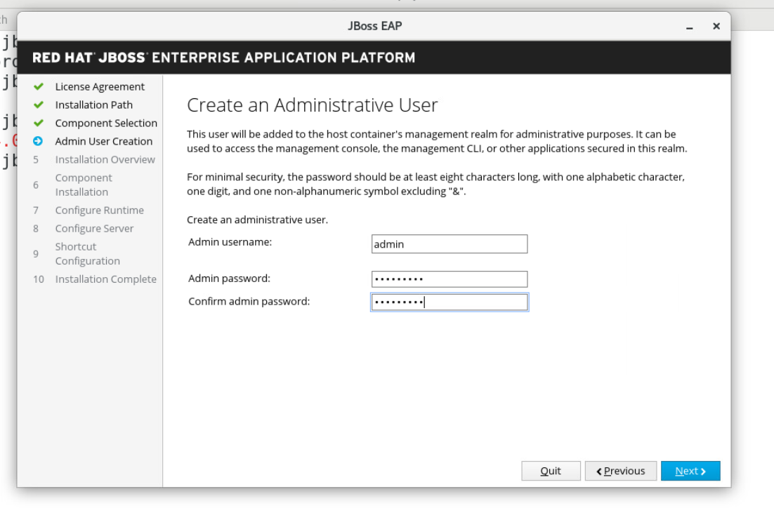

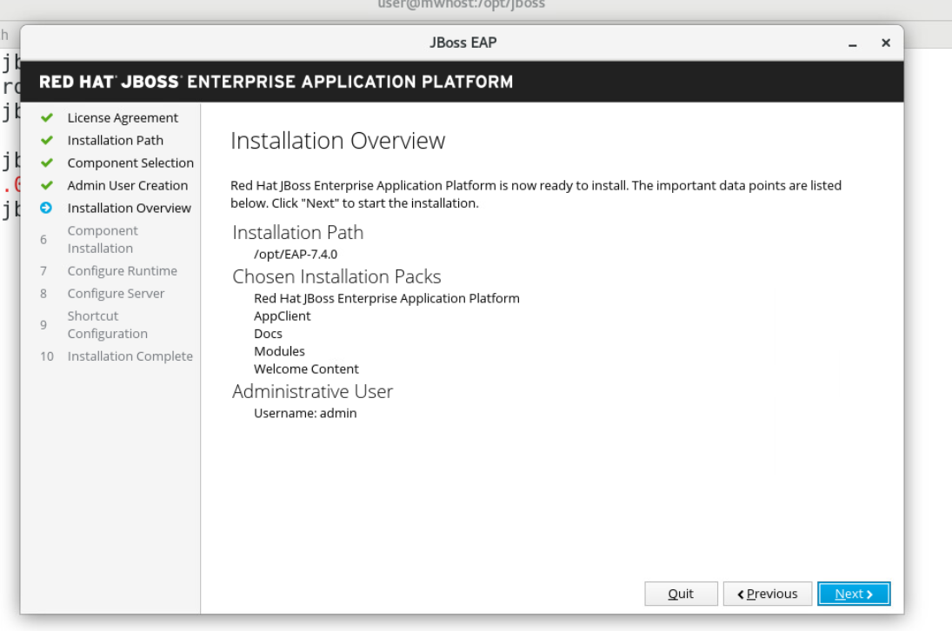

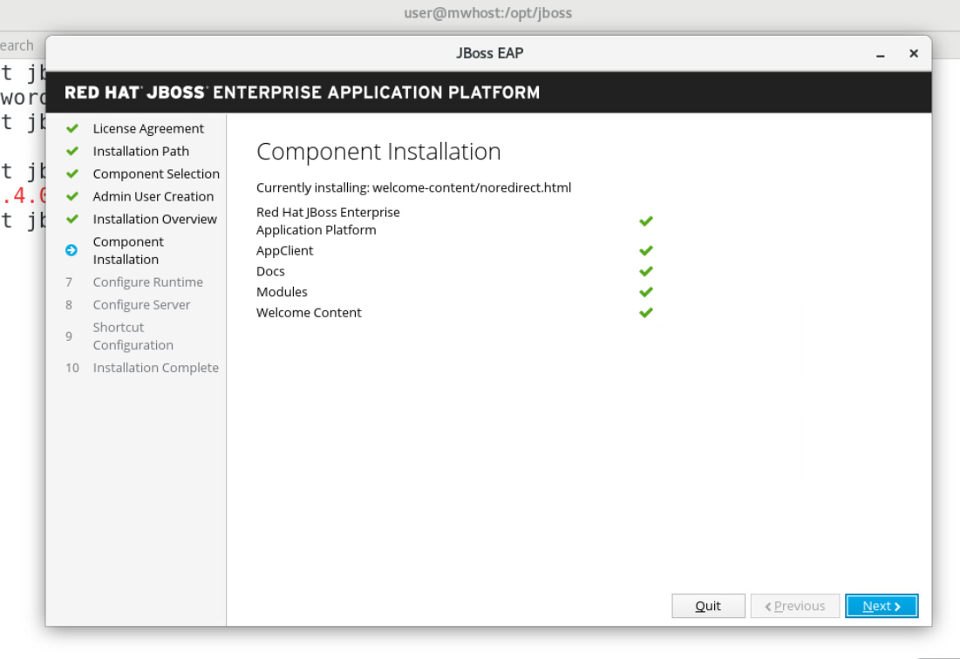

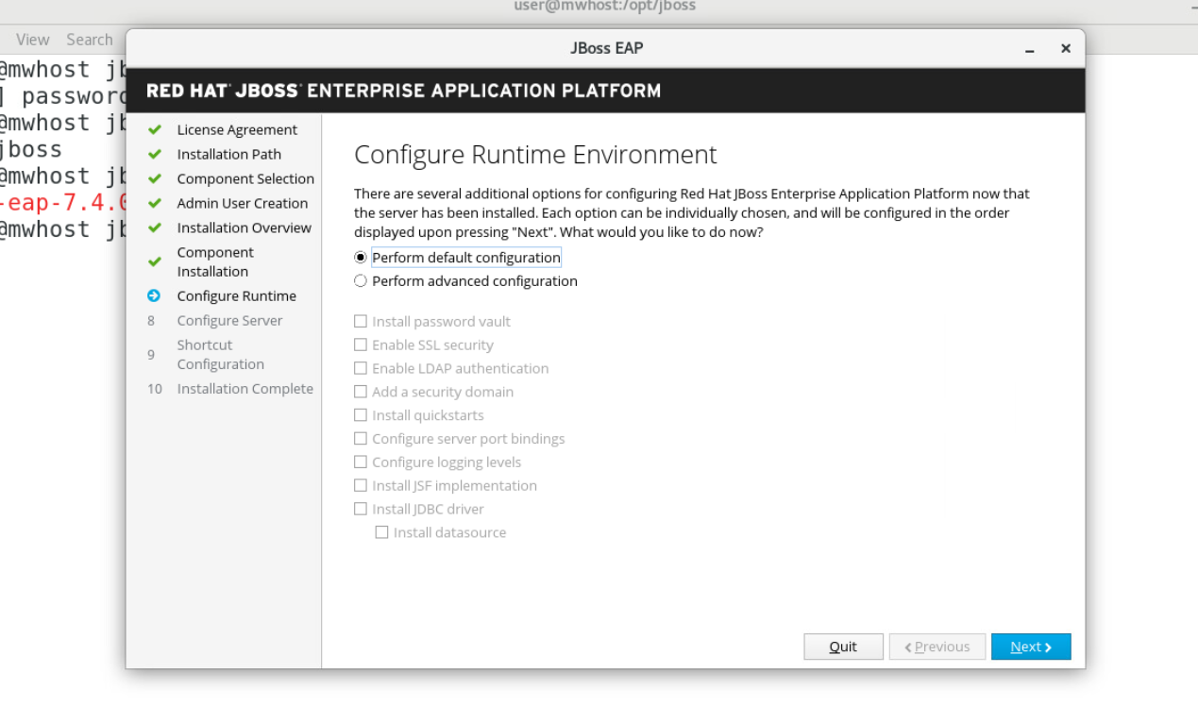

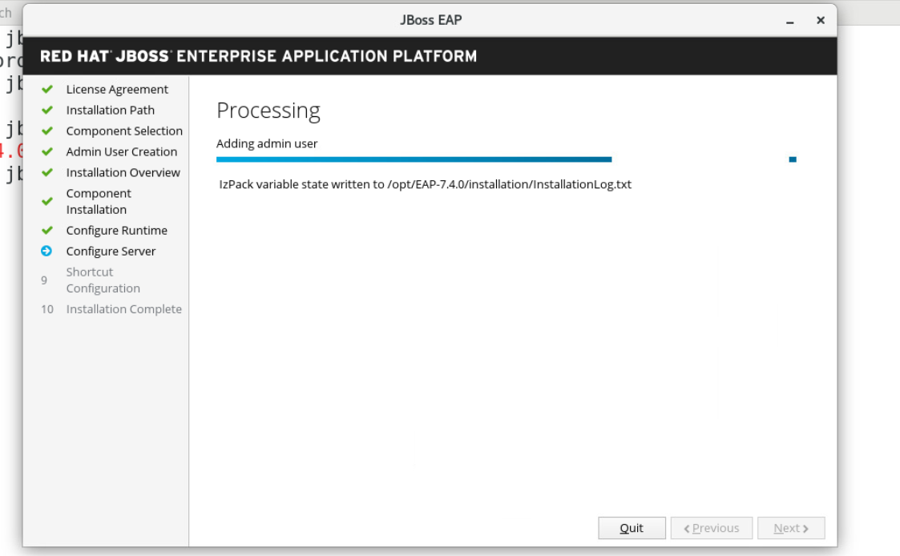

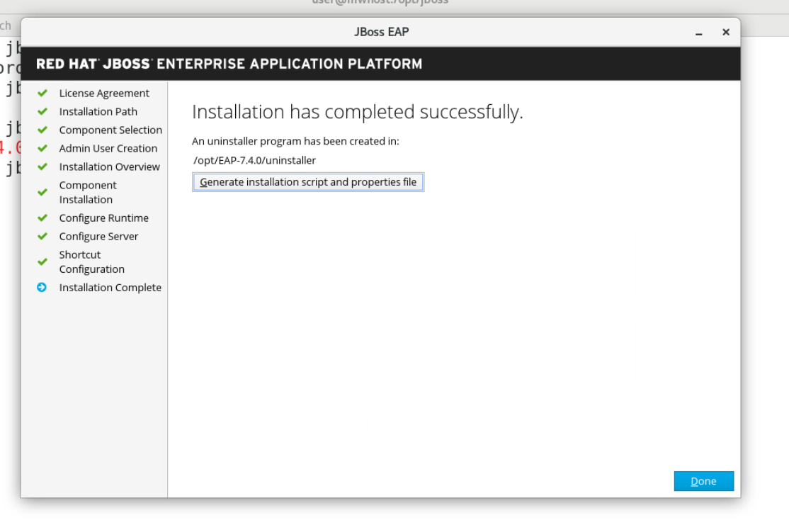

Jboss Home :

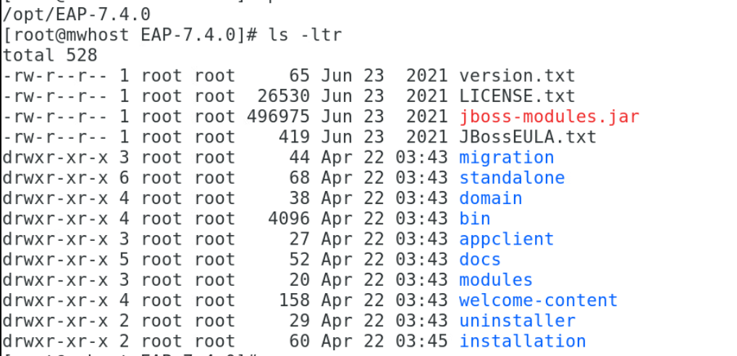

How to take backup of Jboss Standalone/Domain configuration?

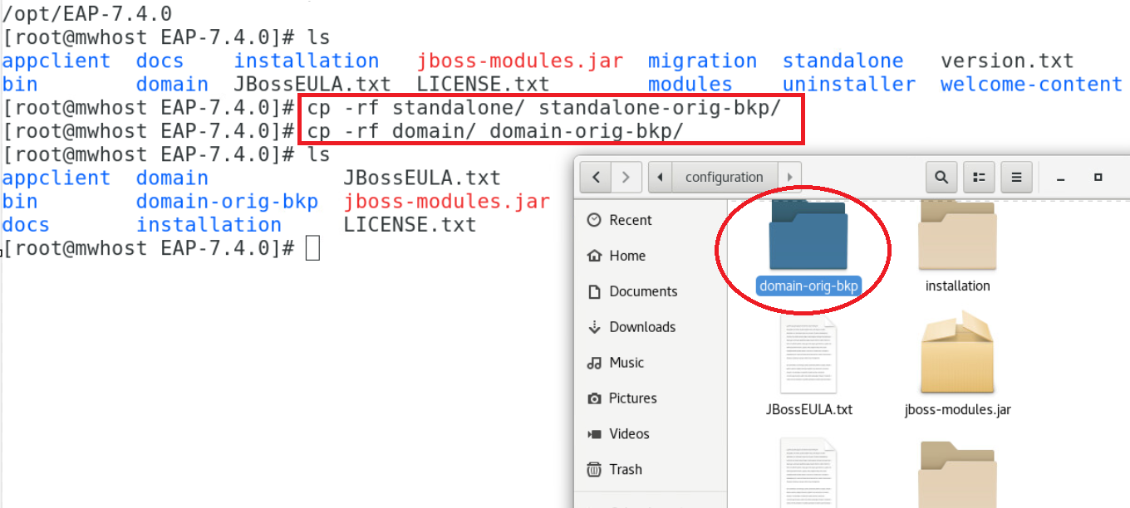

How to create a Management User in JBoss EAP

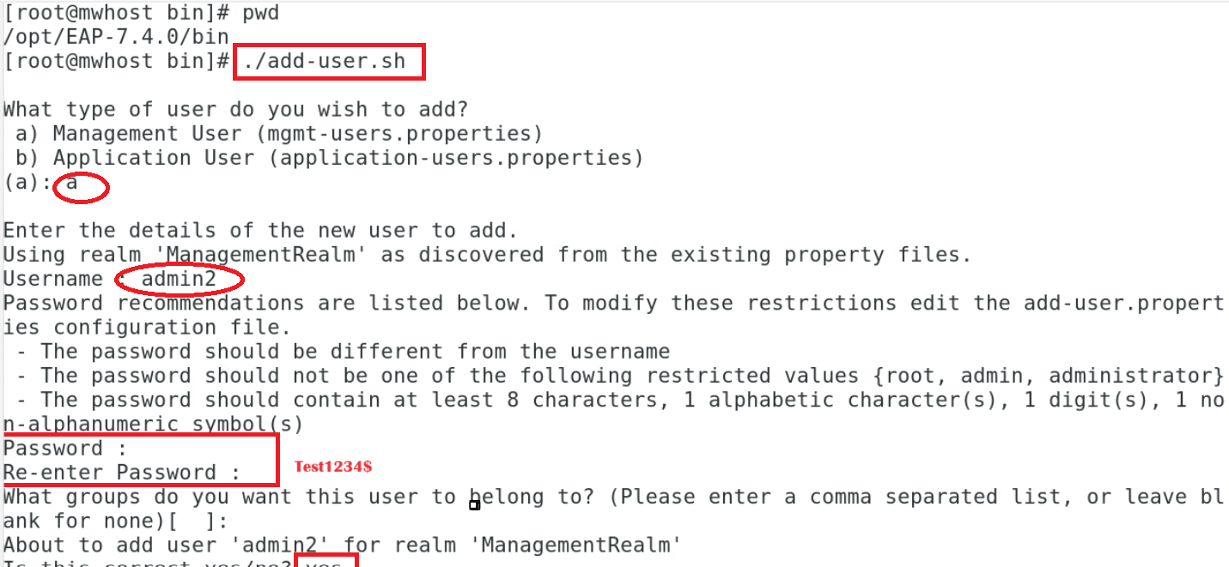

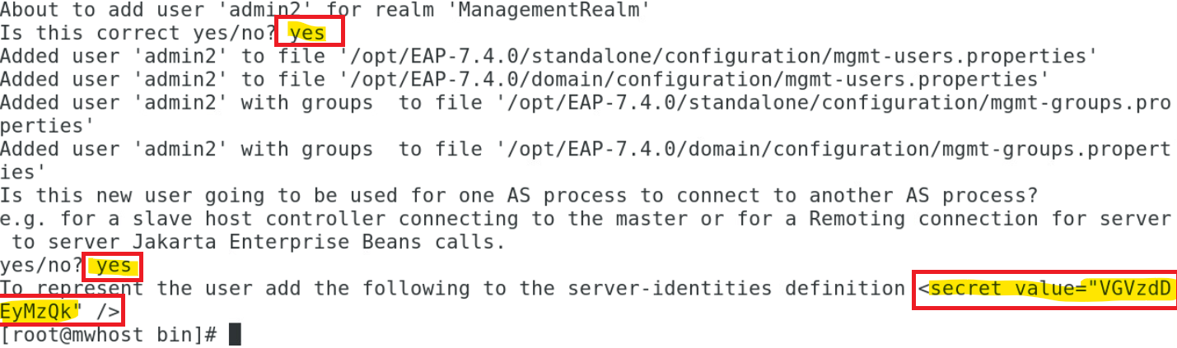

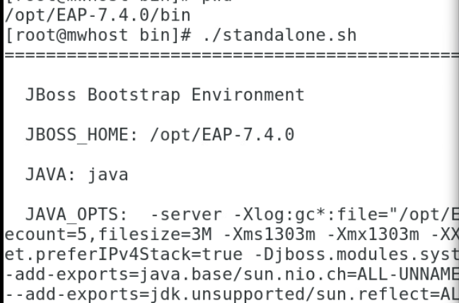

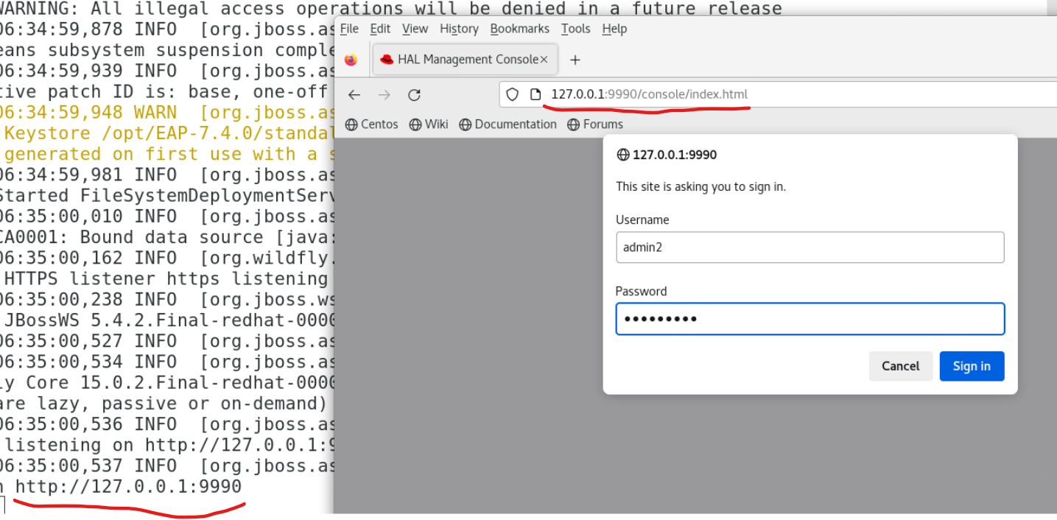

How to start Jboss server using standalone-full profile with ipaddress?

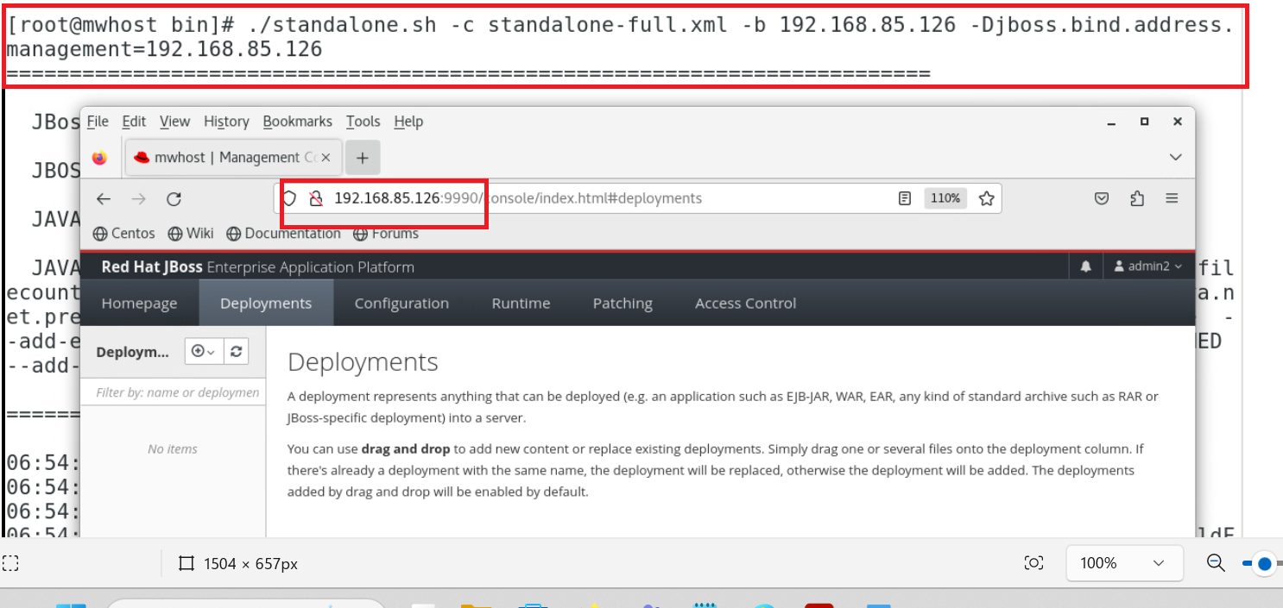

How to start Jboss server using standalone-ha profile with ipaddress?

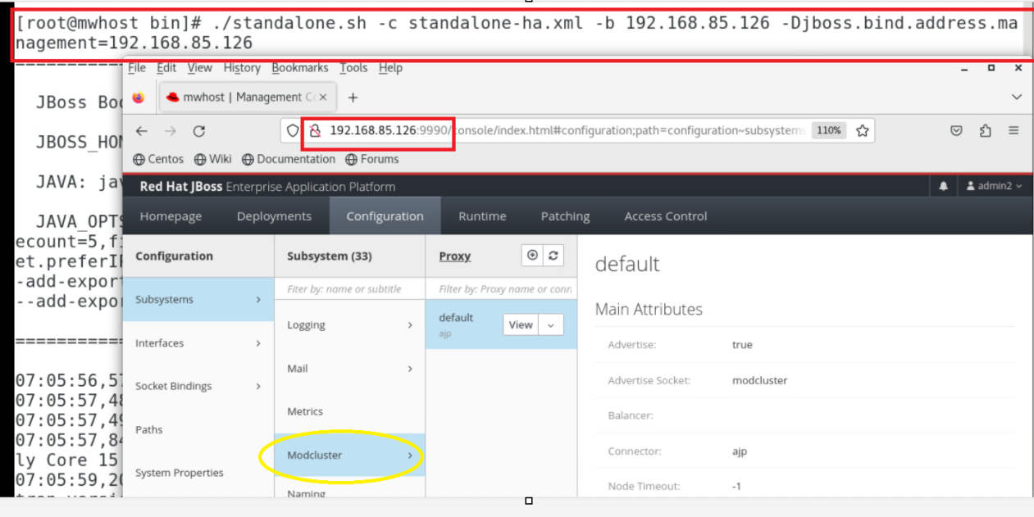

How to start Jboss server using standalone-full-ha profile with ipaddress?

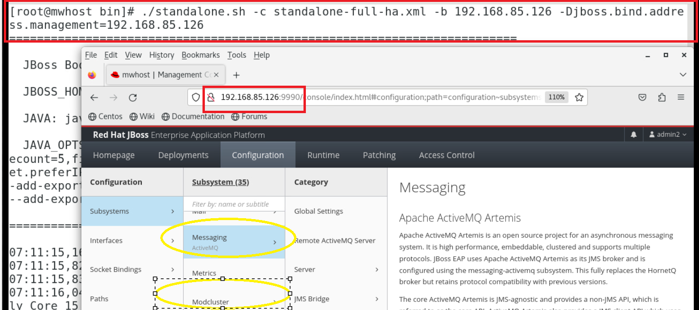

How to create Domain Severs in Jboss?

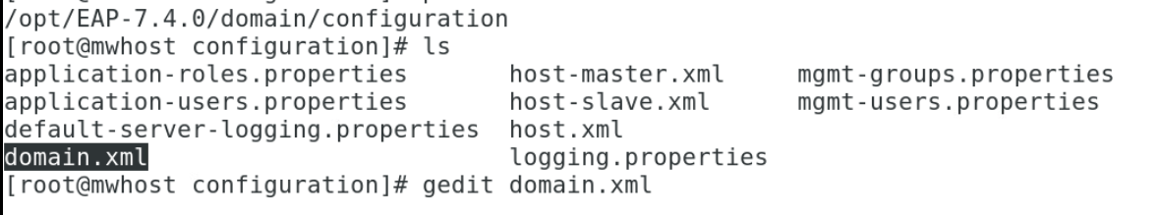

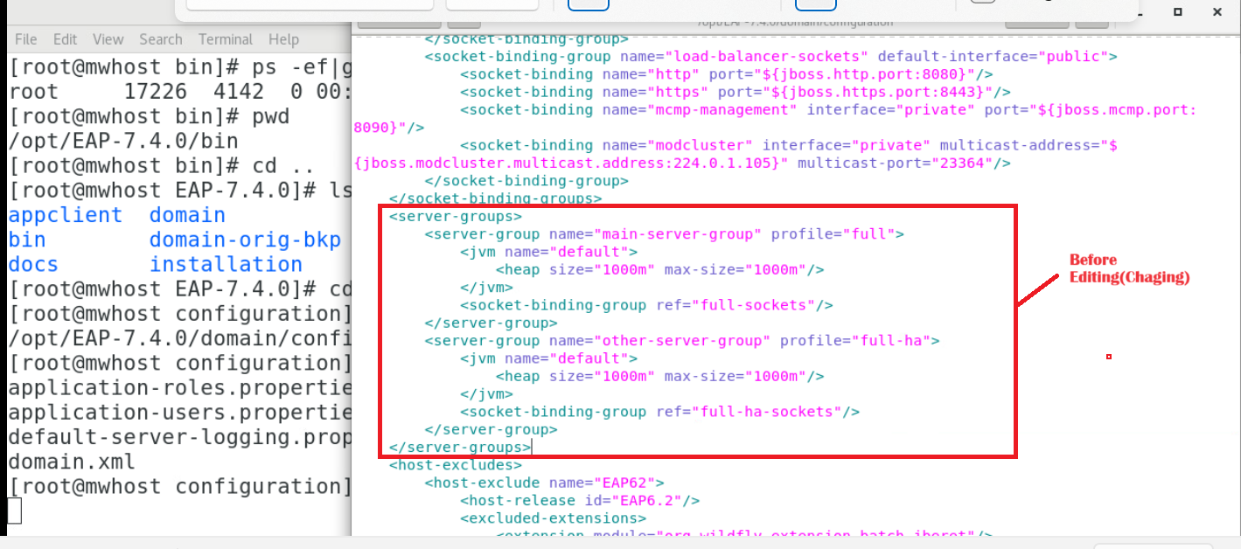

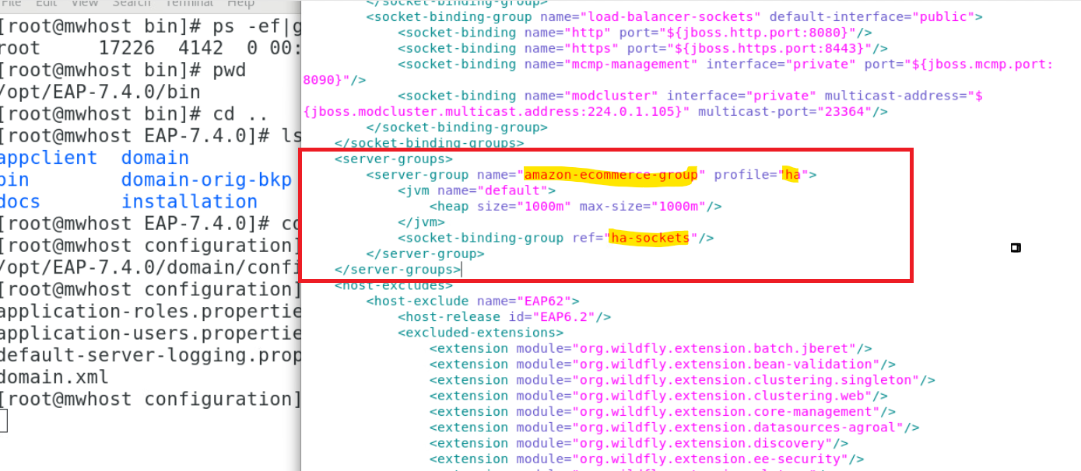

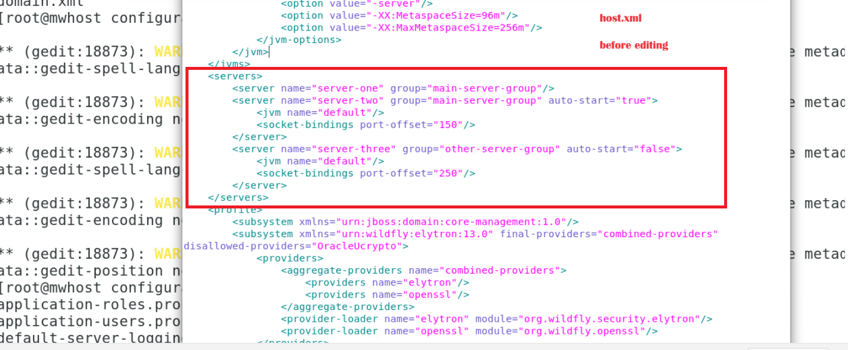

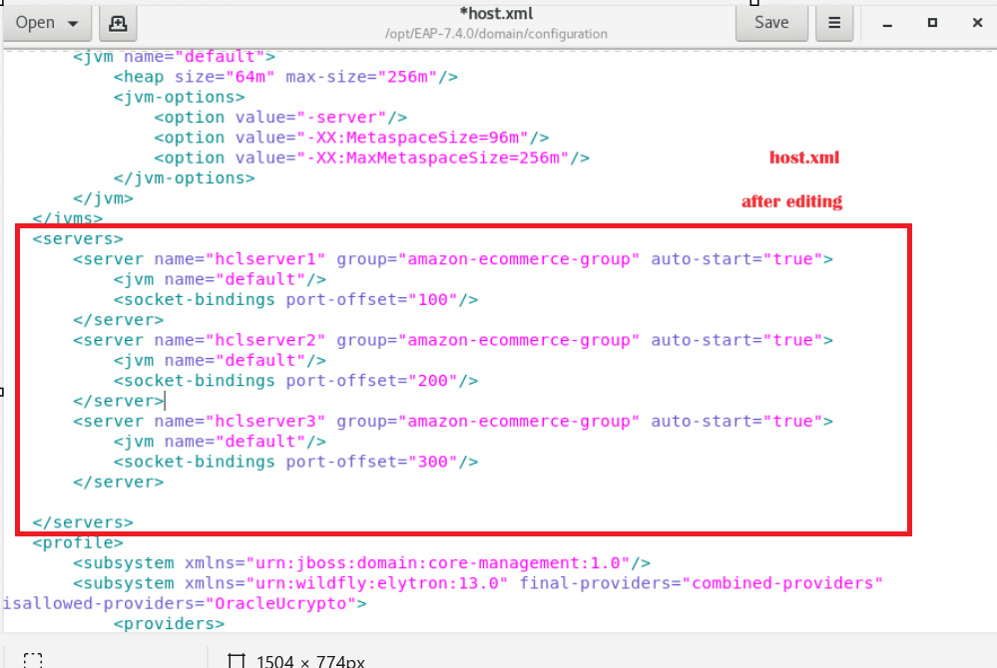

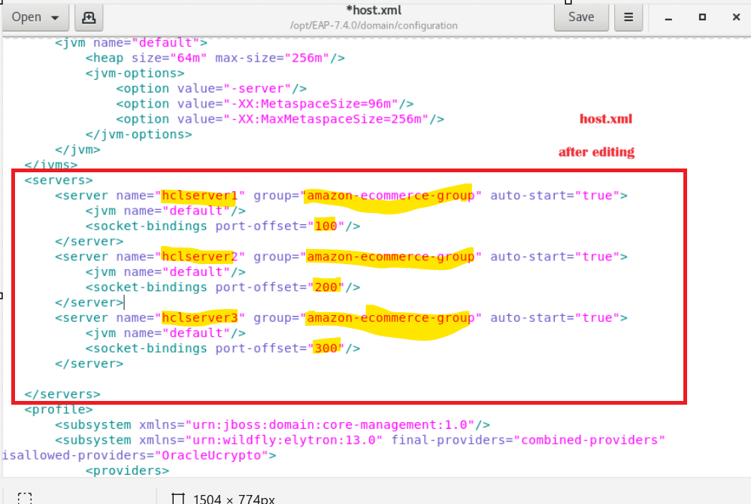

To start the domain server using ipaddress



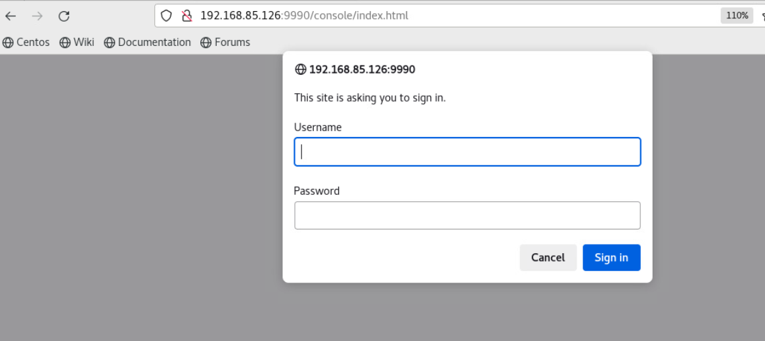

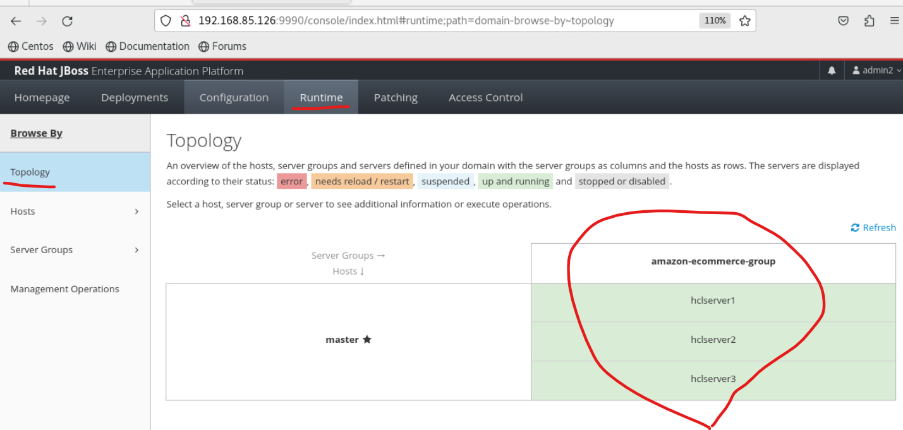

How to stop and start servergroup members in jboss domain using jboss webconsole?

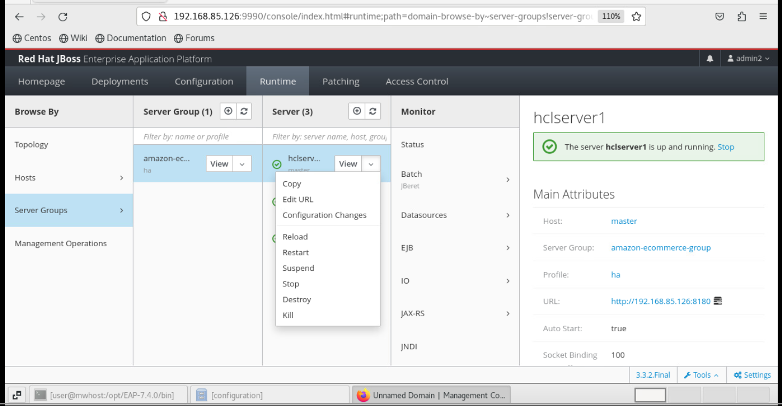

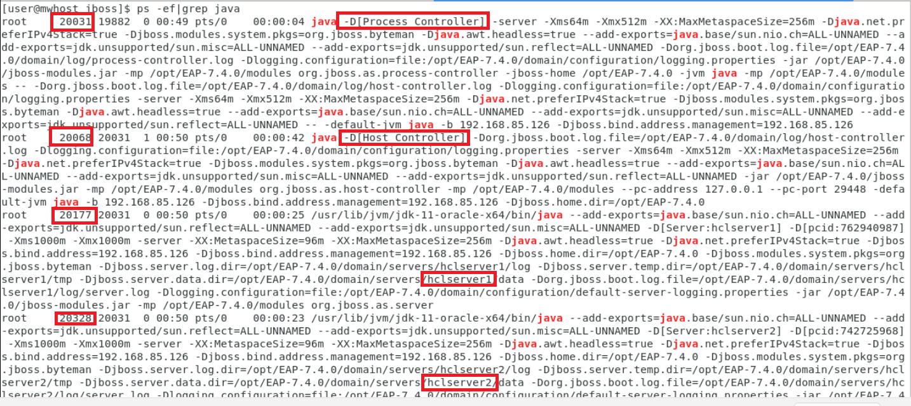

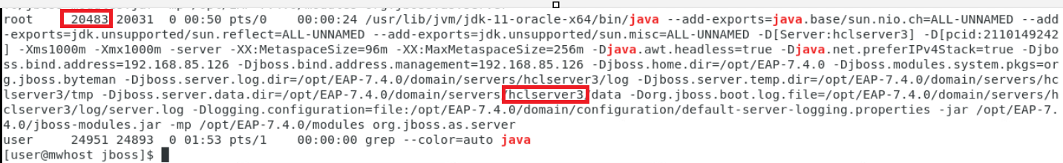

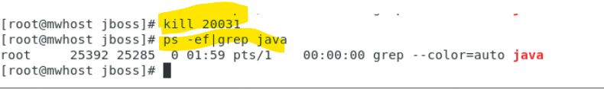

How to run multiple instances of jboss standalone server in the same machine?

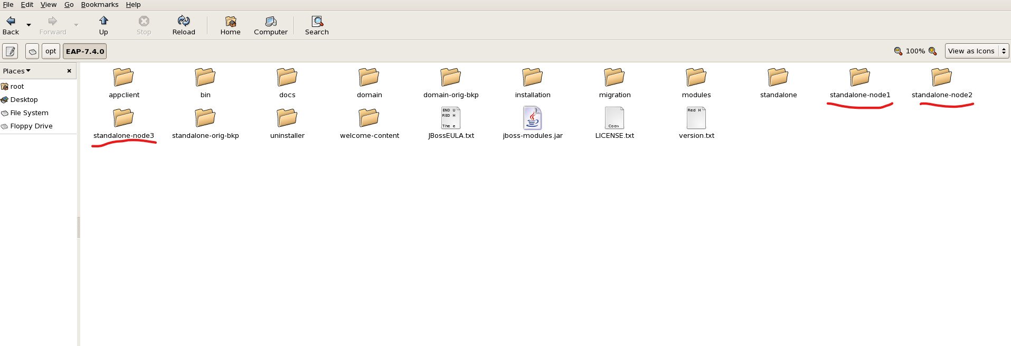

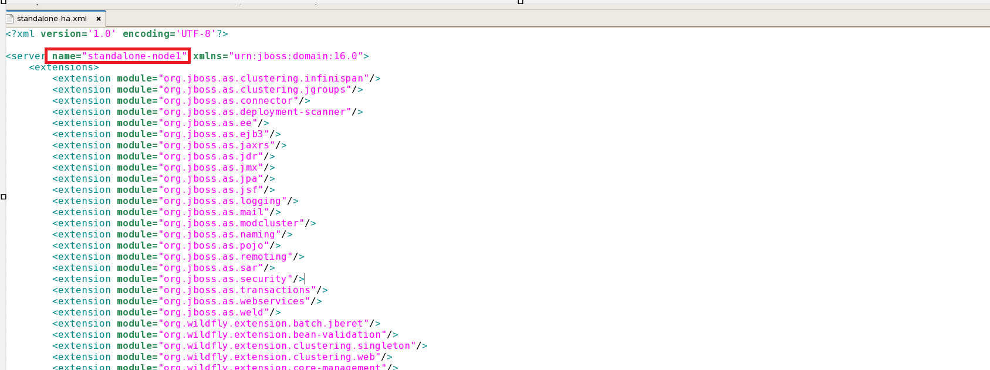

Note: repeat the same changes for standalone-node2/standalone-node3

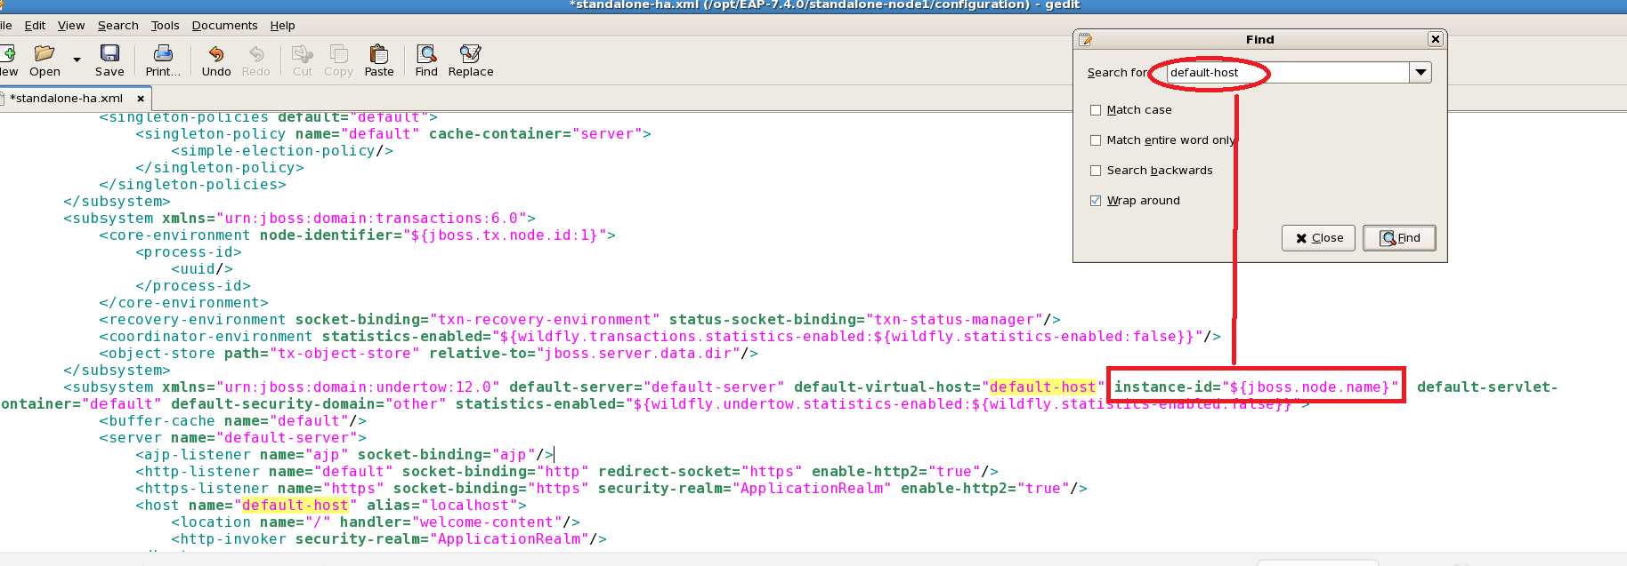

Note: repeat the same changes for standalone-node2/standalone-node3

Like below

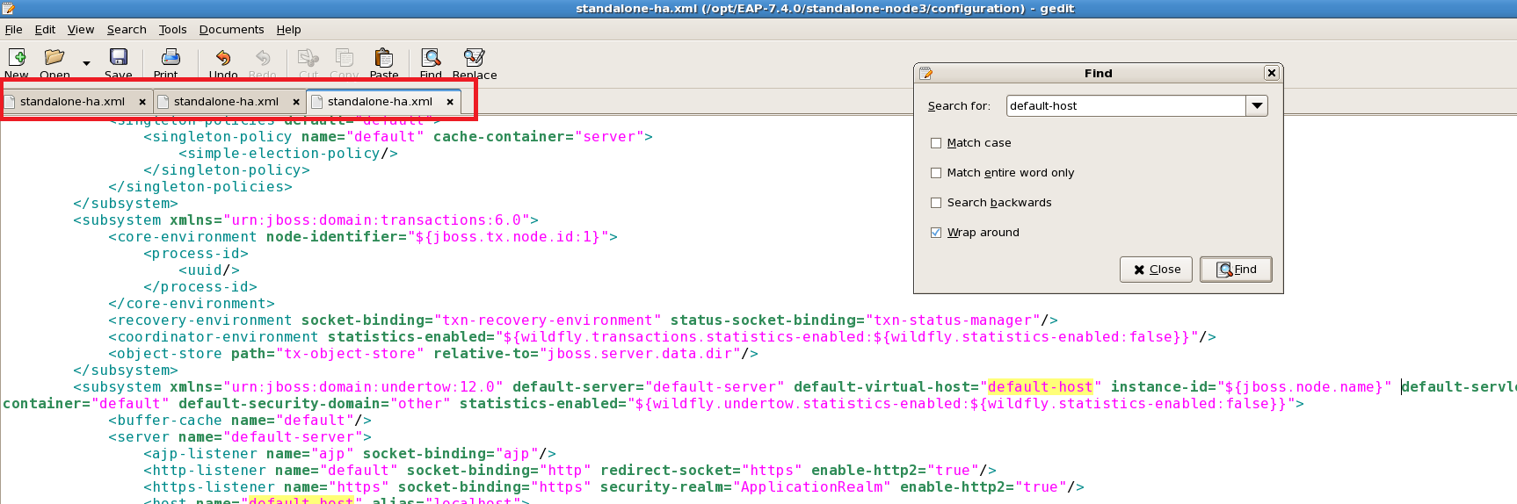

To start standalone-node1

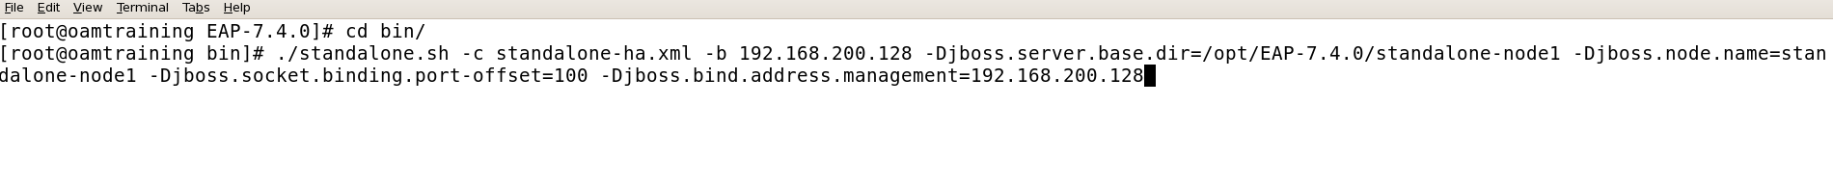

http://192.168.200.128:10090/

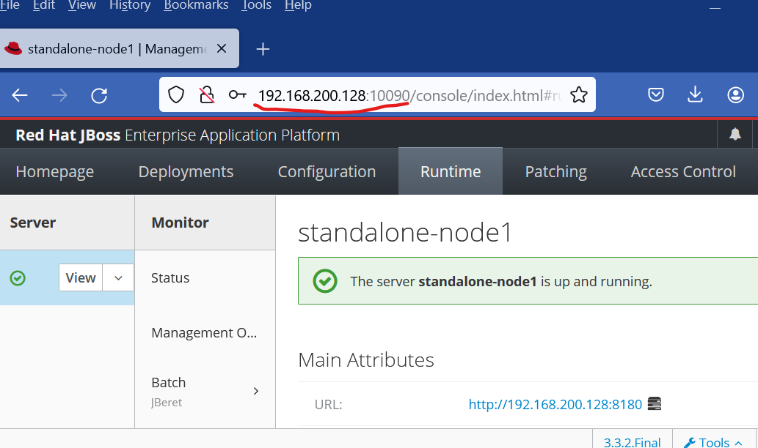

To start standalone-node2

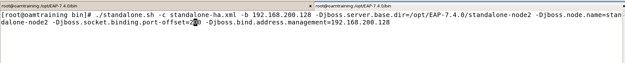

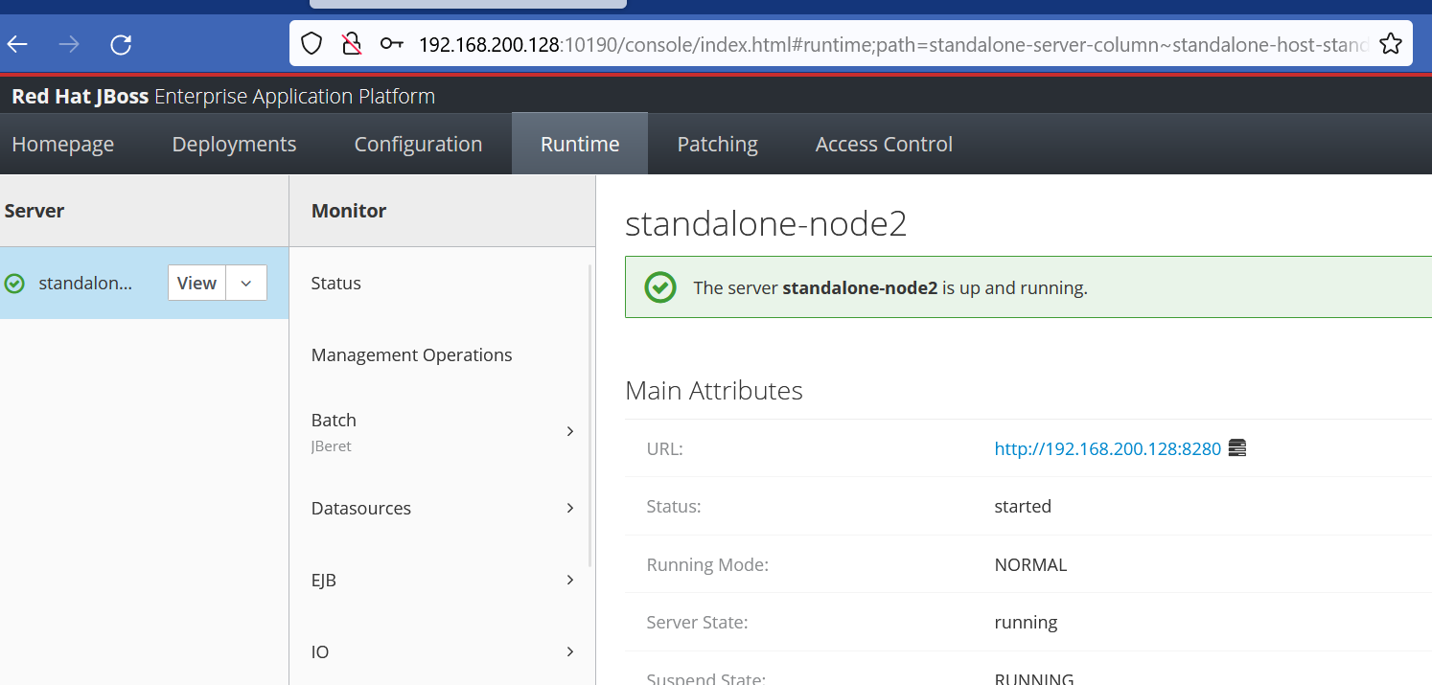

To start standalone-node3



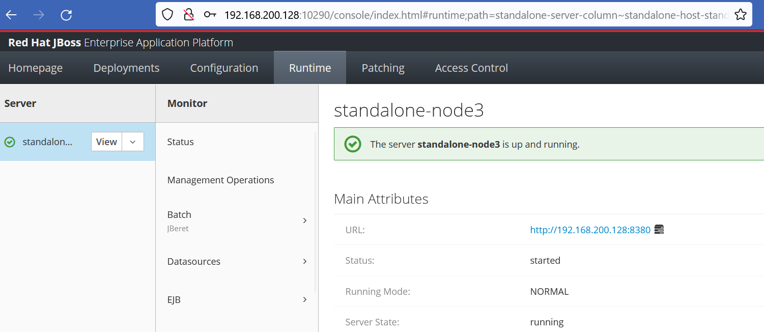

JDBC Datasource

